

Story 3

Transportation Delay

Version 0.1

25.11.2005

Your partner to set your business into real-time

Inhaltsverzeichnis

Story 3 1
Abbildungsverzeichnis 2
Tabellenverzeichnis 2
1 Starting Point 3
2 Preparation 3
3 The Transport 4
4 Acceptance of shipment 5
5 Fazit 5

Abbildungsverzeichnis

Fehler! Es konnten keine Einträge für ein Abbildungsverzeichnis gefunden werden.

Tabellenverzeichnis

Fehler! Es konnten keine Einträge für ein Abbildungsverzeichnis gefunden werden.

- Starting Point

The French central storage depot in Paris announces that their products “Tosalumn” and “Gernazilin” are running out. Therefore an order is given up on the October 3, 2005 to the central storage depot in Vienna. 500 units of “Tosalumn” and 1000 units of “Gernazilin” supplies are ordered. The absolute deadline for resupply would be the October 3, 2005 because of depot exhaustion.

Order | 03.10.2005
Delivery Date | 24.10.2005
Products | “Tosalumn”, 500 Units  “Gernazilin”, 1000 Units
(OrderReceived, OrderConfirmed)

- Preparation

The transport of the ordered goods is tendered to find suitable carriers for the delivery. The route and the terms of delivery are as follows:

Departure | Central storage depot Vienna  18.10.2005
Arrival | Depot Paris  19.10.2005
Transportation budget | EUR 3000,--
Delivery temperature for “Tosalumn” | MinTemp: -10  MaxTemp: -2
Delivery temperature for “Gernazilin” | MinTemp: 0  MaxTemp: 10
(ShipmentTenderIssued)

The carriers Weiss (433) and Fischer (142) have to reject the offer. The carriers would need special equipment for this transport, since two different delivery temperatures in the cooled container must prevail. The carrier Anger (532) owns a truck equipped with this special hardware so they confirm the supply contract.
(ShipmentTenderRejected, ShipmentTenderAccepted)

MediTransCare and the carrier Anger plan together a transportation plan for the goods. The route takes two stages: stage 1 from Vienna to Saarbrücken, stage 2 from Saarbrücken to Paris. The distance is approximately 1300km long and should take about 32 hours including a rest period.

Departure | 7:00, 18.10.2005 central storage depot
Breakpoint | approx. 19:00, 18.10.2005 in Saarbrücken
Arrival | approx. 15:00, 19.10.2005 storage depot in Paris
(ShipmentCreated)

In order to keep the quality standards, as with each cooled supply, dataloggers are deployed for temperature measurement, which log the temperature in 60 minute intervals. The dataloggers are packed together with the products between polystyrene layer by layer to achieve meaningful results.
(DataLoggerConfigured)

The parameters for the planned transport look like as follows:

Stage1 from Vienna to Saarbruecken:
CarrierId | 532 (Anger)
TransportId | 48001
PlannedShipped | 2005-10-18T07:00:00
PlannedDelivered | 2005-10-18T19:00:00
EarlyBuffered | 2005-10-18T07:00:00
LateBuffered | 2005-10-18T20:00:00
Route | Vienna To Saarbruecken
Miles | 570
PlannedFreightCosts | 1200

Stage 2 from Saarbruecken to Paris:
CarrierId | 532 (Anger)
TransportId | 48002
PlannedShipped | 2005-10-19T07:00:00
PlannedDelivered | 2005-10-19T15:00:00
EarlyBuffered | 2005-10-18T20:00:00
LateBuffered | 2005-10-24T16:00:00
Route | Saarbruecken To Paris
Miles | 230
PlannedFreightCosts | 1000

- The Transport

The transport goes out exactly at 7:00 on October 18, 2005 from the central depot in Vienna. Arrived in Saarbrücken the dataloggers are taken from the shipment to read out the temperature values for a routine control.

On the next day around 7:00 the truck driver would like to go on with the transport but he detects a physical defect at the electrical system of the cool container in the truck. The transport could be resumed, but the special cooling in the containers could not be ensured under these circumstances.

The carrier Anger has already informed the service company about the cool containers:
The journey and the repairs take two full days and a loaner vehicle is not available.

The system identifies the late departure from Saarbrücken and contacts a responsible staff member in the company react on the problem. Then he can contact the carrier.

The decision has been made that no other carrier gets the contract to take care about the broken transport because there is enough buffer time left until the deadline on the November 24, 2005. If the repairs would fail and take longer than the assumed two days the truck would have to stay off the road on the coming weekend because there is a ban on driving heavy vehicles in France on weekends.

After the successful repair of the truck the transport starts on the October 21, 2005 at 9:00 in the morning and arrives at 16:11 at the depot in Paris.
(TransportStart, TransportEnd, DataLoggerRead, ShipmentAudit)
- Acceptance of shipment
The supply is unpacked, counted and the dataloggers are evaluated. The products were in the permitted temperature interval over the entire transportation duration.
(DataLoggerRead, ShipmentAudit)

The delivery is taken over and so the transport contract has been fulfilled. The planned date of delivery was overrun for one day, nevertheless it could have been delivered before deadline.
(ShipmentDelivered)

- Conclusion

The system could send a message that something is wrong with the transportation time and it could automatically generate alternative transport routes for the shipment.

If such delays happen more often with this special equipment and with this carrier than it could assume that it would be a risk to give away offers to this carrier if special cooling equipment is needed.

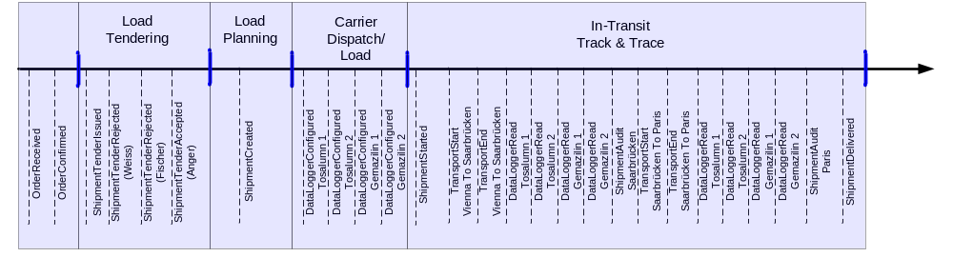

LateBuffer
OrderReceived
OrderReceived.DeliveryDate
Transport Wien - Saarbrücken
Transport Saarbrücken - Paris
ShipmentCreated
Transport Wien - Saarbrücken
Transport Saarbrücken - Paris
Verspäterter Weitertransport erkannt!
Meldung
Weiterüberwachung der Lieferung
…
Geplanter
Zeitablauf

Überwachter
Zeitablauf

